ANTI- BULLYING PLAN
WEST WYALONG PUBLIC SCHOOL
Revised: 2013

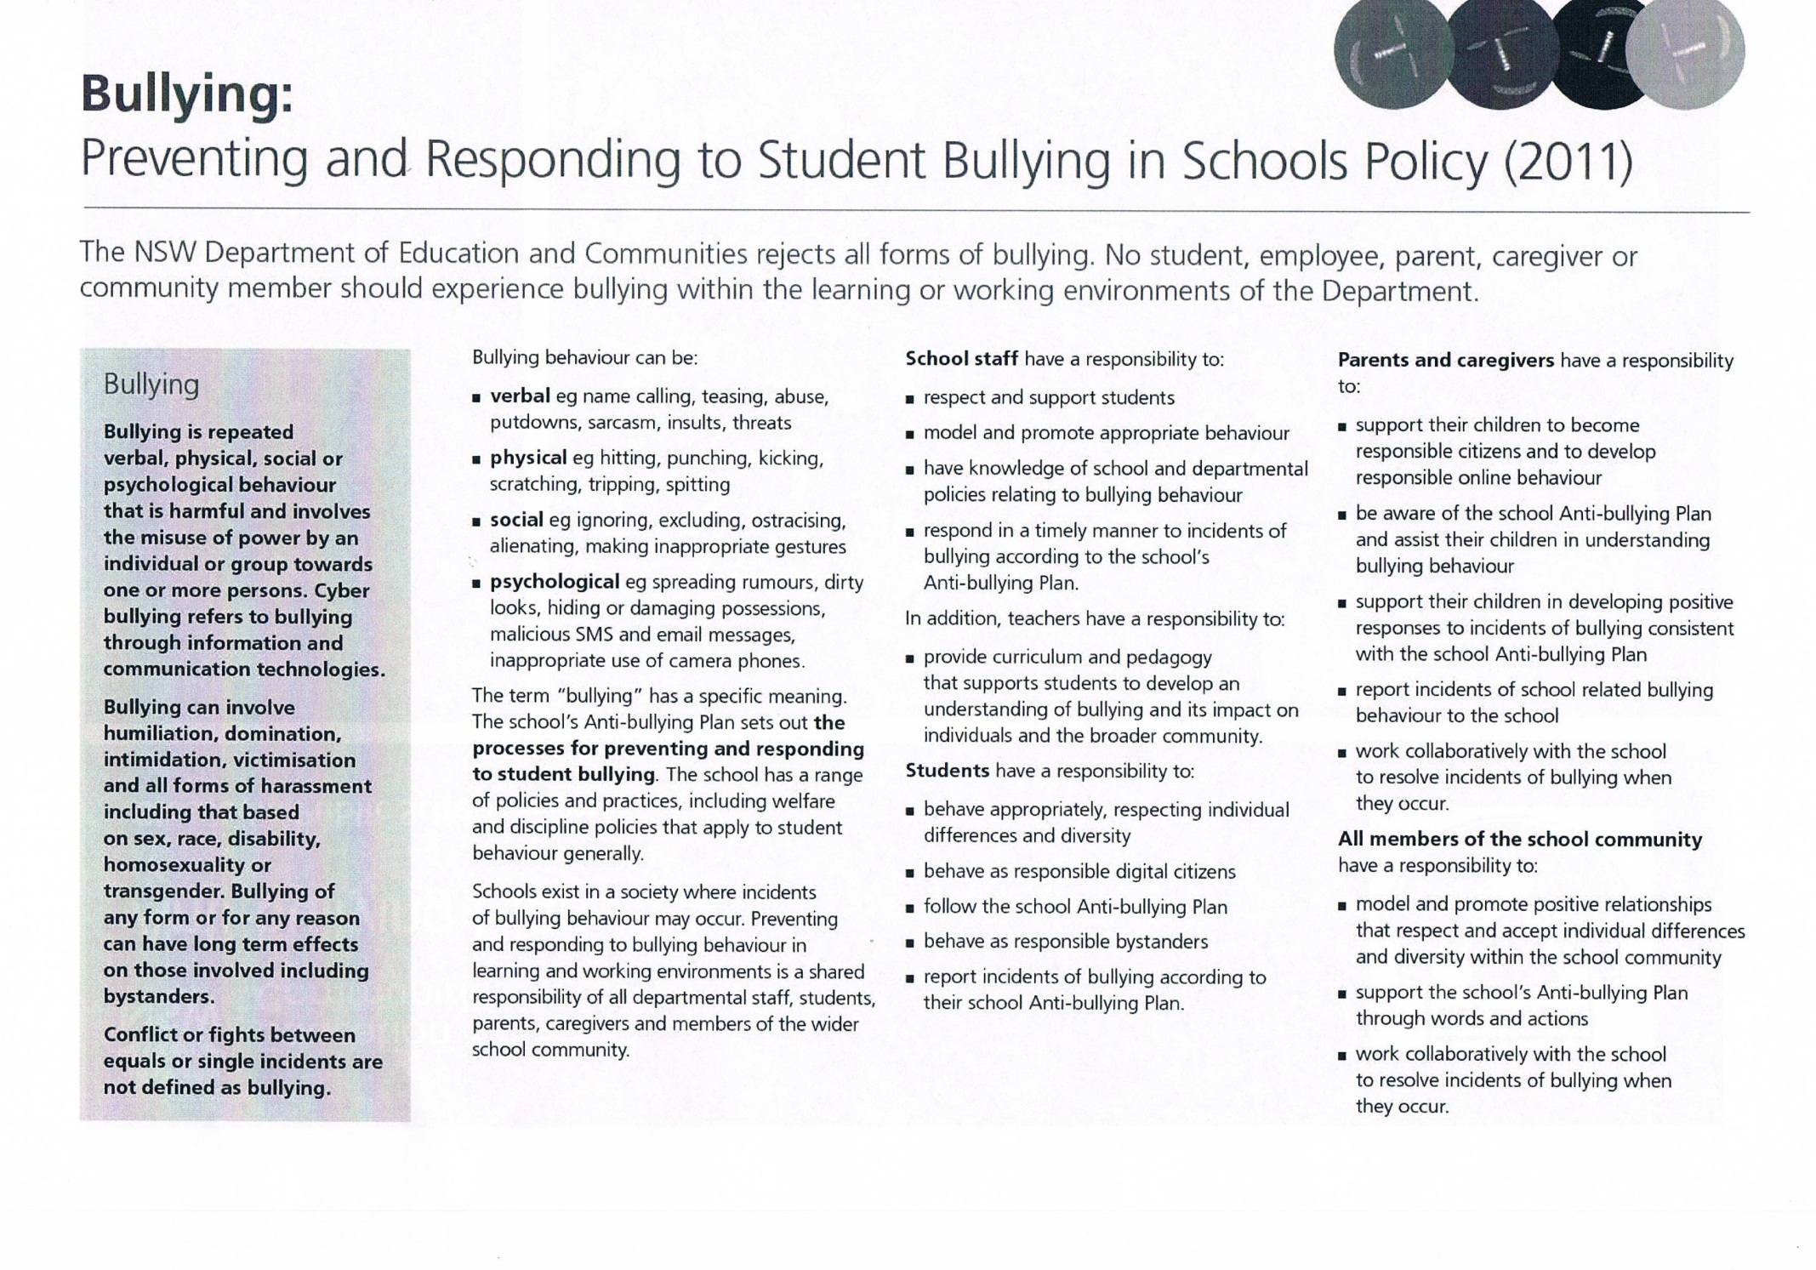WEST WYALONG PUBLIC SCHOOL ANTI-BULLYING PLAN
This plan outlines the processes for preventing and responding to students bullying in our school and reflects the Bullying: Preventing and Responding to Student Bullying in Schools Policy of the NSW Department of Education and Communities.
STATEMENT OF PURPOSE:
At West Wyalong Public School we value and show tolerance of others in a safe and supportive environment. We foster positive relationships through our strong student welfare programs. Our anti-bullying policy aims to deal effectively with and prevent incidences of bullying within the school community.
Students attend West Wyalong Public School to participate in quality education that will help them to become self-directed, lifelong learners who can create a positive future for themselves and the wider community.
Any inappropriate behaviour that gets in the way of teaching and learning at this school and interferes with the wellbeing of students cannot be accepted.
Students, teachers, parents, caregivers and members of the school community can expect:
- That students will be safe at school, free from bullying, harassment, intimidation and victimization
- To be involved in the collaborative development of the school Anti-Bullying Plan
- To know what is expected of them and others in relation to the Anti-Bullying Plan
- That all students will be provided with appropriate support when bullying occurs.
Students, teachers, parents, caregivers and members of the school community have a responsibility to:
- Promote positive relationships that respect and accept individual differences and diversity within the whole school community
- Contribute to the development of the Anti-Bullying Policy and support it through words and actions
- Actively work together to resolve incidents of bullying

PROTECTION
Definition
Bullying is repeated verbal, physical, social or psychological behaviour that is harmful and involves the misuse of power by an individual or groups towards one or more persons.
Cyber bullying refers to bullying THROUGH INFORMATION AND COMMUNICATION TECHNOLOGIES.
Bullying can involve humiliation, domination, victimisation, and all forms of harassment including that based on sex, race, disability or homosexuality.
Bullying of any form or for any reason can have long term effects on those involved including bystanders.
Conflict or fights between equals or single incidents are not defined as bullying.
Different types of Bullying may be:
Physical: Cyberbullying:
*Hitting/punching *sending of abusive texts or emails
*Pushing/shoving *taking or sharing unflattering or private images
*Kicking *Posting unkind messages or inappropriate images on social networking sites
*Throwing objects *Excluding individuals from online chats or other communication
*Taking other’s belongings/stealing from others *Assuming the identity of the victim online
*Damaging other’s belongings *Stealing passwords
*Spitting at others *Blogs/Websites with inappropriate material
*Intimidation- making someone do something they don’t want to do
Verbal: Indirect:
*Threatening *Spreading rumours
*Name calling/teasing *Excluding others
*Swearing at others *Writing notes
*Ridiculing another person because of their actions, *Choosing not to tell if you see another person being bullied
appearance, physical characteristics or cultural background.

Staff responsibilities: Parent’s responsibilities:
*To model appropriate behaviour at all times *To be aware of and support the school’s Anti-Bullying Policy
*To monitor and track incidences of bullying *To take an active role in their child’s school life and be watchful for bullying
*Respond to incidents in a timely and appropriate manner *To encourage their child to adopt learnt strategies to deal with bullying
*Communicate any bullying behaviours to supervisors *To encourage child to tell if they are being bullied
*To implement school programs designed to prevent bullying *To inform the school if any bullying is suspected
*To communicate bullying incidences to parents when needed
Students’ responsibilites:
*To behave appropriately at all times *To show consideration and respect and to support others
*To tell if they are being bullied or see someone being bullied *To attempt to use learnt strategies to deal with incidents
*To participate fully in school’s Anti-Bullying programs
PREVENTION
It is important that the school community address the underlying causes of bullying relating to school organisational issues, learning and teaching issues and relationship issues.
Preventative strategies:
- Education and promotion of school’s anti-Bullying Policy
- Contents of policy placed in Newsletter, on Facebook and discussed at P&C meetings
- Student welfare programs including the school’s core values
- All students K-6 participate in the Resilience program
- Productive and respectful relationships established between all members of school community
- Classroom rules, routines and processes negotiated and applied consistently
- Adequate supervision of students during breaks on playground and classrooms
- Active intervention when bullying occurs.
Strategies to deal with bullying:
- In all cases it is important to ensure- that victims are believed and made safe, that the correct procedures are followed.
- Thorough investigation is to be carried out, witness statements to be taken – appropriate action to prevent further incidents taken and parents to be notified if necessary
- School Counsellor/Welfare teacher intervention
- Reported at school welfare meeting and monitored by Learning Support team and Executive
- Incidences kept on RISC
- Parents and staff work together
Procedures for dealing with bullying behaviour:
- All students have the right to be heard and believed
- Class teacher deals with issues in the classroom according to student welfare policy and class rules
- Teacher on playground duty deals with smaller issues but ongoing issues to be recorded in red book and raised at student welfare meetings. Assistant Principals can be called to playground issues if necessary
- Discussion with students involved- take prompt and appropriate action
- Staff work with student to look at underlying problems and seek solutions
- Principal and Executive work with parents and individuals to identify and deal with bullying behaviours
- School Counsellor and welfare Teacher involved in individual programs if necessary
- Serious bullying incidents are recorded and consequences are in line with Department discipline procedures( DEC Suspension and expulsion of Student Procedures)
- Reinforcement of “Hands Off” Policy
Procedures to deal with Cyber bullying:
- Ensure each student is safe and arrange support, including the involvement of the Child Well Being unit
- Support for the student to be provided with the agreement of student and parent to assist them to work through the effects of cyberbullying and help them implement effective coping strategies
- Student’s parents are contacted to alert them of the issue and ongoing concerns regarding the welfare of the student
- Gather facts about the suspected cyberbullying and implement appropriate responses to address the issue
- Keep evidence of bullying to assist with possible reporting to Police
- Report any concerns to the administrator of the service as most have measures to assist with tracking and blocking.
If the student is distressed by the bullying ensure they are provided with support- including School Counsellor, Helpline numbers.

Procedures for Reporting Bullying:
- Students are to report all bullying to a teacher immediately
- Parents with concerns about bullying should contact the school immediately
- All bullying incidents are to be dealt with seriously and promptly
- Parents of the student being bullied and the student doing the bullying, will be contacted- all staff to be informed at student welfare meeting so students can be monitored in the playground
- In the case of cyberbullying, the Police may need to be contacted to make a report
- Students will be supported by staff and the School Counsellor/Welfare Teacher
- Our Anti- Bullying Plan and the Anti- Bullying Policy are presented to the P&C and placed on the school’s website
Principal’s comment:
Our school recognises that bullying has become a growing issue in society and our school will put programs into place to develop resilience in others and give students strategies to deal with bullying. The school will work closely with any students who attempt to use bullying tactics to gain power. The school’s core values clearly support a culture of trust and cooperation within our school community. This Plan has been developed in consultation with all staff of WWPS (including SAS staff), P&C members, students, School Counsellor and the Learning Support team. It has been communicated through the school website and newsletter and has been taken to P&C meetings.

School contact information:
Ph: 69722157
Fax: 69722818
Email:
Web:

DEC insight staff portal login

Home » Policy & procedures

Policies & procedures
This section provides current Department of Education and Communities policy and related documents.
Bullying: Preventing and Responding to Student Bullying in Schools Policy  This policy sets out the requirements for preventing and responding to student bullying in NSW government schools.  1.Objectives - Policy statement  1.1  The NSW Department of Education and Communities rejects all forms of bullying. No student, employee, parent, caregiver or community member should experience bullying within the learning or working environments of the Department.  2.Audience and applicability  2.1  The policy applies to all NSW government schools and preschools.  2.2  The policy applies to all student bullying behaviour, including cyberbullying, that occurs in NSW government schools and preschools, and off school premises and outside of school hours where there is a clear and close relationship between the school and the conduct of the student.  3.Context  3.1  Bullying is repeated verbal, physical, social or psychological behaviour that is harmful and involves the misuse of power by an individual or group towards one or more persons. Cyberbullying refers to bullying through information and communication technologies.  Bullying can involve humiliation, domination, intimidation, victimisation and all forms of harassment including that based on sex, race, disability, homosexuality or transgender. Bullying of any form or for any reason can have long-term effects on those involved including bystanders.  Conflict or fights between equals or single incidents are not defined as bullying.  3.2  Schools exist in a society where incidents of bullying behaviour may occur. Preventing and responding to bullying behaviour in learning and working environments is a shared responsibility of all departmental staff, students, parents, caregivers and members of the wider school community.  3.3  All members of the school community contribute to the prevention of bullying by modelling and promoting appropriate behaviour and respectful relationships.  3.4  The Complaints Handling Policy establishes the standard approach to resolving complaints, including complaints about the way a reported incident of bullying has been managed. It is required that it be used in all learning and working environments of the Department of Education and Communities.  3.5  For matters involving bullying which affect departmental employees, refer to the Department's Work Health and Safety (WHS) Policy.  3.6  Document history and details  4.Responsibilities and delegations  4.1  Principals  4.1.1  Principals must ensure that the school implements an Anti-bullying Plan that:  - is developed collaboratively with students, school staff, parents, caregivers, and the community  - includes strategies for:  - developing a shared understanding of bullying behaviour that captures all forms of bullying including cyberbullying  - developing a statement of purpose that outlines individual and shared responsibilities of students, parents, caregivers and teachers for preventing and responding to bullying behaviour  - maintaining a positive climate of respectful relationships where bullying is less likely to occur  - developing and implementing programs for bullying prevention  - embedding anti-bullying messages into each curriculum area and in every year  - developing and implementing early intervention support for students who are identified by the school as being at risk of developing long-term difficulties with social relationships  - developing and implementing early intervention support for those students who are identified at or after enrolment as having previously experienced bullying or engaged in bullying behaviour  - empowering the whole school community to recognise and respond appropriately to bullying, harassment and victimisation and behave as responsible bystanders  - developing and publicising clear procedures for reporting incidents of bullying to the school  - responding to incidents of bullying that have been reported to the school quickly and effectively  - matching a planned combination of interventions to the particular incident of bullying  - providing support to any student who has been affected by, engaged in or witnessed bullying behaviour  - providing regular updates, within the bounds of privacy legislation, to parents or caregivers about the management of the incidents  - identifying patterns of bullying behaviour and responding to such patterns  - monitoring and evaluating the effectiveness of the Plan  - reporting annually to the school community on the effectiveness of the Plan  - includes procedures consistent with DN10/00225 – Reporting incidents involving assaults, threats, intimidation or harassment and the Incident Reporting Policy (Intranet only)  - includes procedures for contacting the child wellbeing unit or Community Services where appropriate  - includes contact information for the police youth liaison officer (YLO) and school liaison police officer (SLP) where appropriate  - includes contact information for appropriate support services such as Kids Helpline  - includes information on departmental appeal procedures and the Complaints Handling Policy  - is promoted and widely available within the school community and published on any school website  - is reviewed with the school community at least every three years.  4.2  School staff  4.2.1  School staff have a responsibility to:  - respect and support students  - model and promote appropriate behaviour  - have knowledge of school and departmental policies relating to bullying behaviour  - respond in a timely manner to incidents of bullying according to the school’s Anti-bullying Plan.  In addition, teachers have a responsibility to:  - provide curriculum and pedagogy that supports students to develop an understanding of bullying and its impact on individuals and the broader community.  4.3  Students  4.3.1  Students have a responsibility to:  - behave appropriately, respecting individual differences and diversity  - behave as responsible digital citizens  - follow the school Anti-bullying Plan  - behave as responsible bystanders  - report incidents of bullying according to their school Anti-bullying Plan.  4.4  Parents and caregivers  4.4.1  Parents and caregivers have a responsibility to:  - support their children to become responsible citizens and to develop responsible on-line behaviour  - be aware of the school Anti-bullying Plan and assist their children in understanding bullying behaviour  - support their children in developing positive responses to incidents of bullying consistent with the school Anti-bullying Plan  - report incidents of school related bullying behaviour to the school  - work collaboratively with the school to resolve incidents of bullying when they occur.  4.5  The school community  4.5.1  All members of the school community have the responsibility to:  - model and promote positive relationships that respect and accept individual differences and diversity within the school community  - support the school’s Anti-bullying Plan through words and actions  - work collaboratively with the school to resolve incidents of bullying when they occur.  5.Monitoring, evaluation and reporting requirements  5.1  Principals are responsible for:  - implementing the policy within the school  - submitting a copy of the school’s Anti-bullying Plan to the school education director whenever it is reviewed  - reporting annually to their school community on the effectiveness of the school’s Anti-bullying Plan  5.2  Directors, Public Schools are responsible for monitoring the local implementation of this policy and reporting to the regional director.  5.3  Executive Directors, Public Schools are responsible for ensuring the regional implementation of the policy.  6.Contact  Leader, Social Inclusion, Ph: (02) 9244 5189. |  | edit  Implementation Date  - 2011-03-21  .  Reference No.  - PD/2010/0415/V01  .  Implementation documents  - Bullying: Preventing and Responding to Student Bullying in Schools Guidelines (pdf 1,137 kb)  - Bullying: Preventing and Responding to Student Bullying in Schools Planning Document (doc 620 kb)  - Anti-bullying Plan Template (doc 517 kb)  .  Related information  - Student Welfare Policy  - Values in NSW Public Schools  - Cyberbullying. Information for staff in schools.  - Anti-bullying Resources (Intranet Only)  - Bullying Interventions. Information for school executive, Learning Support Teams or Student Welfare Teams. (Intranet Only)  - Bias Based Bullying  - Student Discipline in Government Schools Policy  - Incident Reporting Policy (Intranet only)  - Core Rules in NSW Government Schools  - Code of Conduct  - Work Health and Safety (WHS) Policy  - Complaints Handling Policy
www.nsw.gov.au
Page last updated: 03/04/2014
Translated Documents| Conditions of use| Acronyms & abbreviations| Help
Contact us | Report incorrect, out-of-date, or missing information

